Objective of Experiment:
- Implement a single-layer perceptron to classify linearly separable data.
- Design and train an MLP for solving XOR classification.

Pre-Requisite:
Tools: Python, Jupyter Notebook, TensorFlow, Keras

Theory:

- Artificial Neuron: Neuron is a processing element inspired by how the brain works. Similar to biological neuron, each artificial neuron will be do some computation. Each neuron is interconnected to other neurons. Similar to brain, the interconnections between neurons store the knowledge it learns. The knowledge is stored as parameters.

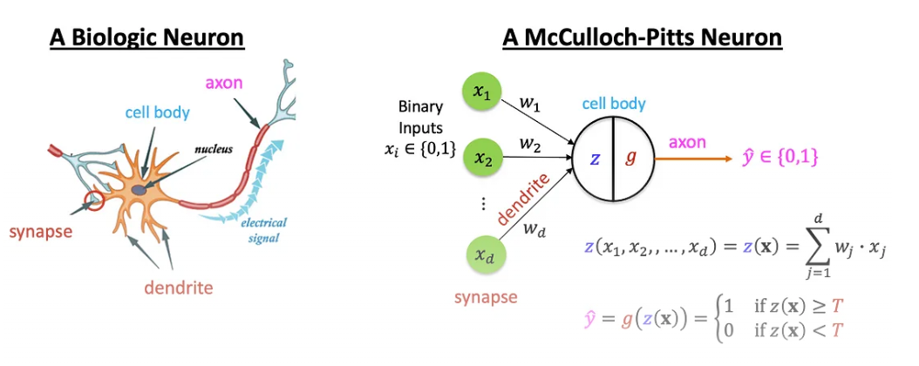
Figure 1: A biological neuron and an artificial neuron [1]

- Properties of Artificial Neural Nets (ANNs)
- Many neuron-like threshold switching units.
- Many weighted interconnections among units.
- Highly parallel, distributed process.
- Emphasis on tuning parameters or weights automatically.

- Perceptron
One type of ANN system is based on a unit called a perceptron. A perceptron takes a vector of real-valued inputs, calculates a linear combination of these inputs, then outputs a 1 if the result is greater than some threshold and-1 otherwise.

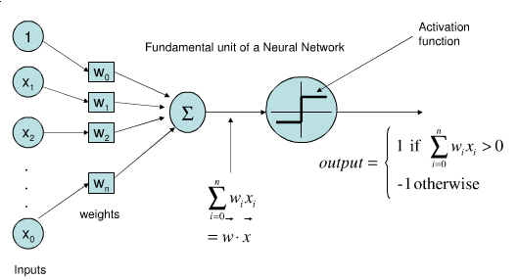
Figure 2: Perceptron [2]

- Representing Logic Gates using Perceptron
Any linear decision can be represented by either a linear regression equation or a Boolean equation. In this experiment, we will represent the above using a Perceptron.

Example: Perceptron for AND gate
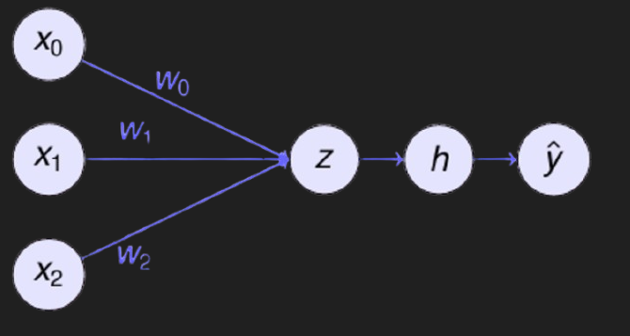
Figure 3: Perceptron for AND gate

Perceptron equation is: $\hat{y}= w_{o}x_{o}+ w_{1}x_{1}+ w_{2}x_{2}$.
$h>0$ for output to be 1.

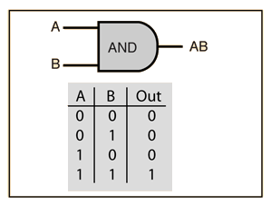
Figure 3: Truth table of AND Gate [3]

Table 1: Perceptron for AND
$$x_{1}$$ | $$x_{2}$$ | t | h
-1 | -1 | -1 | $$w_{0}+ w_{1}\left(-1\right)+ w_{2}\left(-1\right)<0$$
-1 | 1 | -1 | $$w_{0}+ w_{1}\left(-1\right)+ w_{2}\left(1\right)<0$$
1 | -1 | -1 | $$w_{0}+ w_{1}\left(1\right)+ w_{2}\left(-1\right)<0$$
1 | 1 | 1 | $$w_{0}+ w_{1}\left(1\right)+ w_{2}\left(1\right)>0$$

Solving for the inequalities at each row of the truth table, one solution is $w_{1}= w_{2}=2 , w_{0}= -1$. This gives a beautiful linear decision boundary.

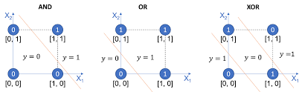

Figure 4: Decision Boundary for AND, OR and XOR Gates [5].

- Perceptron Learning Algorithm
$w_{i} ← w_{i} + ∆w_{i}$ where $∆w_{i}= η (t-o)x_{i}$
$t=c(\vec{x})$ is the target value,
$o$ is perceptron output
$η$ is small constant (e.g., 0.1) called Learning Rate

Convergence of Perceptron Learning Algorithm
It can be proved that the algorithm will converge if training data is linearly separable. Learning rate is sufficiently small. The role of the learning rate is to moderate the degree to which weights are changed at each step. It is usually set to some small value (e.g., 0.1) and is sometimes made to decay as the number of weight-tuning iterations increases.

Representational Power of perceptron: A perceptron represents a hyperplane decision surface in the n-dimensional space of examples. The perceptron outputs a 1 for examples lying on one side of the hyperplane and outputs a -1 for examples lying on the other side.

- Non-linearly Separable Data:
Two groups of data points are non-linearly separable in a 2-dimensional space if they cannot be easily separated with a linear line.

Perceptron for XOR Gate
The challenge is that data is non-linearly separable as seen in the Decision boundary for XOR (fig. 4).
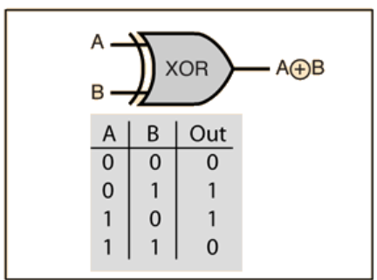
Figure 5: Truth table of XOR Gate [3]

Solution for XOR [6]
- Use multi-layer perceptron (MLP)
- Introduce another layer in between the input and the output)
- This in-between layer is called hidden layer.

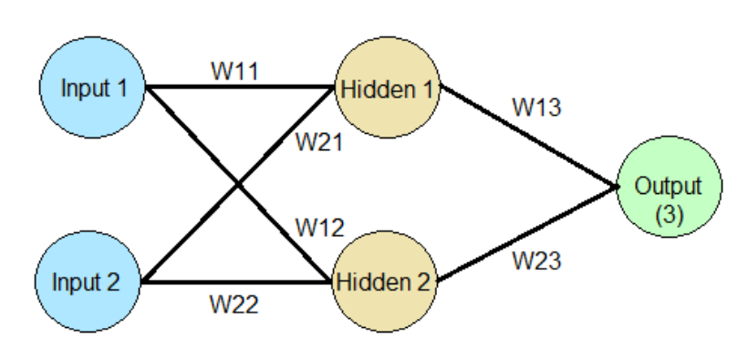
Figure 6: Neural Network Model for learning XOR [8]

$W_{11}= W_{21}= W_{13}= W_{23}=1$ , $W_{12}= W_{22}=- 1$
The threshold $th$ for Hidden node $n_{1}$ is $1$, for Hidden node $n_{2}$ is $-1$ and for Output node $n_{3}$ is $2$.

Table 2: MLP for XOR
$$x_{1}$$ | $$x_{2}$$ | $$n_{1}$$ | $$n_{2}$$ | $n_{3}$ =  $$x_{1} xor x_{2}$$
0 | 0 | $$0⋅1+0⋅1=0 ≯th$$  $$n_{1}=0$$ | $$0⋅\left(-1\right)+0⋅\left(-1\right)=0 >th$$  $$n_{2}=1$$ | $$0⋅1+1⋅1=1 ≯ th$$  $$n_{3}=0$$
0 | 1 | $$0⋅1+1⋅1=1 ≥th$$  $$n_{1}=1$$ | $$0⋅\left(-1\right)+1⋅\left(-1\right)= -1≥th$$  $$n_{2}=1$$ | $$1⋅1+1⋅1=2 ≥ th$$  $$n_{3}=1$$
1 | 0 | $$1⋅1+0⋅1=1 ≥th$$  $$n_{1}=1$$ | $$1⋅\left(-1\right)+0⋅\left(-1\right)= -1≥th$$  $$n_{2}=1$$ | $$1⋅1+1⋅1=2 ≥ th$$  $$n_{3}=1$$
1 | 1 | $$1⋅1+1⋅1=2 ≥th$$  $$n_{1}=1$$ | $$1⋅\left(-1\right)+1⋅\left(-1\right)= -2≯th$$  $$n_{2}=0$$ | $$1⋅1+0⋅1=1 ≯ th$$  $$n_{3}=0$$

The Challenge is how to learn the parameters (weights) and threshold? The solution for learning is to Use the gradient descent algorithm, which we will cover in Experiment 3 (Optimization of Deep Neural Networks).

- Power of Multilayer Perceptions (MLP):
- MLP can be used for both binary and multiclass classification.
- Regression where outputs are real values.
- Representing complex decision boundaries. A MLP with 2 hidden layers can be used to represent complex decision boundaries one perceptron is responsible to realize one straight line.
- Representing Boolean functions.
MLP is called a universal approximator for the above reasons.

Problem Description:
- Implement a single-layer perceptron to classify linearly separable data.

- Design and train an MLP for solving XOR classification.

Input <write here>

Methods used in Libraries <write here>

Algorithm <write here>

Program <write here>

Output <screenshot>

Post Lab Questions to be attempted:
Q1. (x1, x2) are input features and target classes are either +1 or -1 as shown in the figure. x2 is never negative. A fully connected multilayer perceptron network is used for classification with 100% accuracy. Step activation functions are used at all nodes, i.e., output=+1 if total input >= bias b at a node, else output = -1.
- What is the minimum number of hidden layers and minimum number of hidden nodes in each hidden layer required?
- Obtain the equations of the decision boundaries.
- Specify all weights and bias values at all nodes. Weights can be only +/-5 or 0, and bias 0 or +ve multiples of 5 only. Draw the minimal network architecture with obtained weights and bias values. Organize the nodes in each layer horizontally and show the node representing x1 at the left on the input layer. Organize the hidden nodes in ascending order of bias at that node. Show all calculation steps.
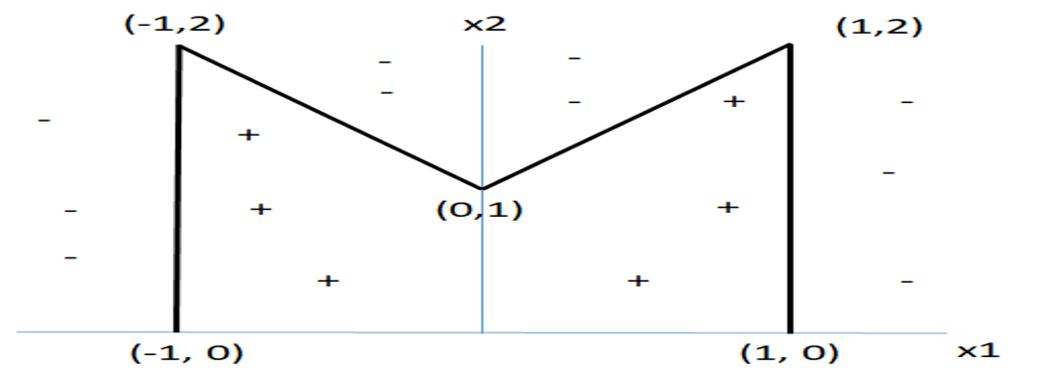

Q2. Consider the binary classification problem given below:
- How many perceptrons and how many layers are required to classify the above points with 100% accuracy.
- Sketch the MLP architecture with appropriate weights and biases to classify the above data points.
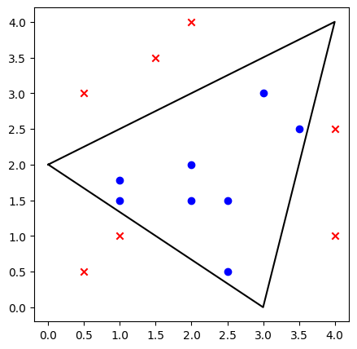

1) Single-Layer Perceptron (from scratch) — classify a linearly separable dataset
Input
Two-dimensional points with binary labels (+1 / -1). Example: AND gate points or synthetic separable clusters.
Methods used / Libraries
numpy, matplotlib for data & plotting
Perceptron implemented from scratch (perceptron learning rule)

Algorithm (Perceptron Learning Rule)
- Initialize weight vector w (including bias) randomly or zeros.
- For each epoch, iterate through training examples (x, y):
- compute activation = sign(w ⋅ x)
- update: w = w + lr * (y - y_pred) * x (or classic rule w = w + lr * y * x when y ∈ {+1,-1} and y_pred ∈ {+1,-1} and update only when misclassified).
- Repeat until no misclassifications or max epochs reached.
import numpy as np
import matplotlib.pyplot as plt
from matplotlib.colors import ListedColormap
%matplotlib inline

def plot_data(X, y, w=None, title=''):
plt.figure(figsize=(6,6))
# scatter
pos = y==1
neg = y==-1
plt.scatter(X[pos,0], X[pos,1], marker='o', label='+1', edgecolor='k', s=80)
plt.scatter(X[neg,0], X[neg,1], marker='s', label='-1', edgecolor='k', s=80)
# decision boundary
if w is not None:
# w: [w0 (bias), w1, w2]
b, w1, w2 = w[0], w[1], w[2]
# x range
xs = np.array([X[:,0].min()-1, X[:,0].max()+1])
# avoid division by zero:
if abs(w2) > 1e-6:
ys = -(b + w1*xs)/w2
plt.plot(xs, ys, 'k--', linewidth=2, label='decision boundary')
plt.xlabel('x1'); plt.ylabel('x2'); plt.title(title)
plt.legend(); plt.grid(True)
plt.xlim(X[:,0].min()-1, X[:,0].max()+1)
plt.ylim(X[:,1].min()-1, X[:,1].max()+1)
plt.gca().set_aspect('equal', adjustable='box')
plt.show()

# Prepare a simple linearly separable dataset (AND gate extended with real-valued points)
# AND gate points (converted to -1/+1)
X = np.array([[0,0],[0,1],[1,0],[1,1]], dtype=float)
y = np.array([-1, -1, -1, 1]) # AND -> +1 only for (1,1)

# Add a tiny jitter to make plotting nicer
rng = np.random.RandomState(1)
X = X + 0.05 * rng.randn(*X.shape)

plot_data(X, y, title='Training data (AND)')

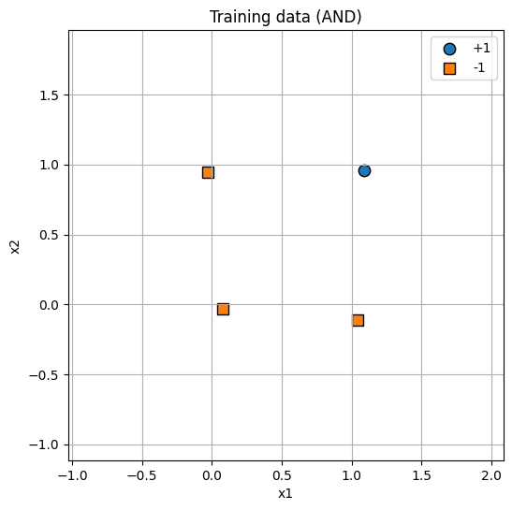

class Perceptron:
def __init__(self, lr=0.1, n_iters=1000, random_state=1):
self.lr = lr
self.n_iters = n_iters
self.rng = np.random.RandomState(random_state)
self.w = None # includes bias as w[0]

def fit(self, X, y):
n_samples, n_features = X.shape
# Augment X with bias term of 1
X_aug = np.hstack([np.ones((n_samples,1)), X])
# Initialize weights small random
self.w = self.rng.normal(scale=0.01, size=(n_features+1,))
for epoch in range(self.n_iters):
errors = 0
for xi, yi in zip(X_aug, y):
activation = np.dot(self.w, xi)
y_pred = 1 if activation >= 0 else -1
if y_pred != yi:
# classic perceptron update
self.w += self.lr * yi * xi
errors += 1
# stop early if no errors
if errors == 0:
#print(f'Converged at epoch {epoch}')
break
return self

def predict(self, X):
X_aug = np.hstack([np.ones((X.shape[0],1)), X])
activations = X_aug.dot(self.w)
return np.where(activations >= 0, 1, -1)

# Train
perc = Perceptron(lr=0.1, n_iters=100)
perc.fit(X, y)
print('Weights (bias, w1, w2):', perc.w)

# Plot decision boundary
plot_data(X, y, w=perc.w, title='Perceptron decision boundary (AND)')

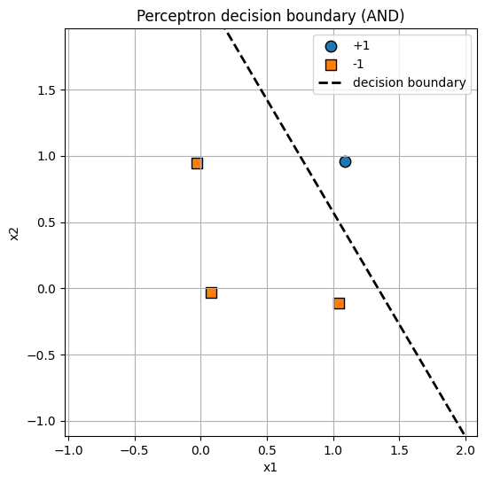
import matplotlib.pyplot as plt
# Recreate figure and save
plt.figure(figsize=(6,6))
pos = y==1; neg = y==-1
plt.scatter(X[pos,0], X[pos,1], marker='o', label='+1', edgecolor='k', s=80)
plt.scatter(X[neg,0], X[neg,1], marker='s', label='-1', edgecolor='k', s=80)
b, w1, w2 = perc.w[0], perc.w[1], perc.w[2]
xs = np.array([X[:,0].min()-1, X[:,0].max()+1])
if abs(w2) > 1e-6:
ys = -(b + w1*xs)/w2
plt.plot(xs, ys, 'k--', linewidth=2, label='decision boundary')
plt.xlabel('x1'); plt.ylabel('x2'); plt.title('Perceptron (saved image)')
plt.legend(); plt.grid(True)
plt.gca().set_aspect('equal', adjustable='box')
plt.savefig('/content/perceptron_and.png', dpi=150)
plt.show()
print("Saved plot to /content/perceptron_and.png")

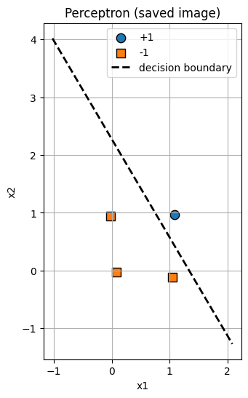

2. MLP (Multi-Layer Perceptron) for XOR Classification
XOR is not linearly separable; a small MLP with one hidden layer of at least 2 hidden units can solve it.
Input
XOR truth table inputs (0/1) with targets 0/1 (we will use 0/1 for Keras with sigmoid / binary_crossentropy).
Libraries / Methods used
tensorflow + keras (tf.keras)
numpy, matplotlib for plotting

Algorithm
- Build a small MLP with one hidden layer (2 neurons), activation tanh or relu, output neuron with sigmoid.
- Train with gradient descent-based optimizer (Adam) and binary_crossentropy.
- Evaluate predictions (threshold at 0.5).

import numpy as np
import matplotlib.pyplot as plt
import tensorflow as tf
from tensorflow.keras.models import Sequential
from tensorflow.keras.layers import Dense
from tensorflow.keras.optimizers import Adam
%matplotlib inline

print("TensorFlow version:", tf.__version__)

TensorFlow version: 2.19.0

# Prepare XOR data
X_xor = np.array([[0,0],[0,1],[1,0],[1,1]], dtype=float)
y_xor = np.array([[0],[1],[1],[0]], dtype=float) # 0/1 targets

# optional: shuffle and small noise (not necessary)
rng = np.random.RandomState(2)
X_xor = X_xor + 0.02 * rng.randn(*X_xor.shape)

plt.figure(figsize=(4,4))
plt.scatter(X_xor[:,0], X_xor[:,1], c=y_xor.flatten(), cmap=plt.cm.Paired, s=120, edgecolor='k')
plt.title('XOR dataset'); plt.xlabel('x1'); plt.ylabel('x2'); plt.grid(True)
plt.show()

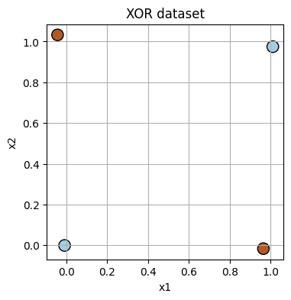

# Build MLP model (small)
model = Sequential([
Dense(4, input_shape=(2,), activation='tanh', name='hidden1'), # 2-4-1 works; we'll use 4 neurons for robustness
Dense(1, activation='sigmoid', name='output')
])
model.compile(optimizer=Adam(learning_rate=0.05), loss='binary_crossentropy', metrics=['accuracy'])
model.summary()

/usr/local/lib/python3.12/dist-packages/keras/src/layers/core/dense.py:93: UserWarning: Do not pass an `input_shape`/`input_dim` argument to a layer. When using Sequential models, prefer using an `Input(shape)` object as the first layer in the model instead.
super().__init__(activity_regularizer=activity_regularizer, **kwargs)

Model: "sequential"

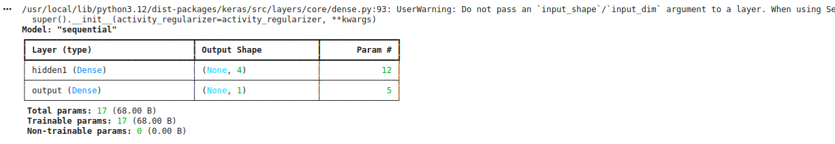
Total params: 17 (68.00 B)

Trainable params: 17 (68.00 B)

Non-trainable params: 0 (0.00 B)

# Train
history = model.fit(X_xor, y_xor, epochs=500, verbose=0, batch_size=4)
# show final metrics
loss, acc = model.evaluate(X_xor, y_xor, verbose=0)
print(f'Final loss: {loss:.4f}, accuracy: {acc:.4f}')

Output: Final loss: 0.0017, accuracy: 1.0000

# Predictions and decision surface plotting
preds = model.predict(X_xor)
print('Raw predictions (probabilities):\n', preds.flatten())
print('Rounded predictions (0/1):\n', (preds >= 0.5).astype(int).flatten())

# plot decision boundary over a grid
xx = np.linspace(-0.5, 1.5, 200)
yy = np.linspace(-0.5, 1.5, 200)
XX, YY = np.meshgrid(xx, yy)
grid = np.vstack([XX.ravel(), YY.ravel()]).T
Z = model.predict(grid).reshape(XX.shape)

plt.figure(figsize=(6,6))
plt.contourf(XX, YY, Z, levels=[-0.01,0.5,1.01], alpha=0.3)
plt.scatter(X_xor[:,0], X_xor[:,1], c=y_xor.flatten(), edgecolor='k', s=120)
plt.title('MLP decision regions for XOR')
plt.xlabel('x1'); plt.ylabel('x2'); plt.grid(True)
plt.show()

1/1 ━━━━━━━━━━━━━━━━━━━━ 0s 59ms/step
Raw predictions (probabilities):
[1.1299255e-04 9.9877167e-01 9.9764365e-01 2.9587511e-03]
Rounded predictions (0/1):
[0 1 1 0]
1250/1250 ━━━━━━━━━━━━━━━━━━━━ 3s 2ms/step

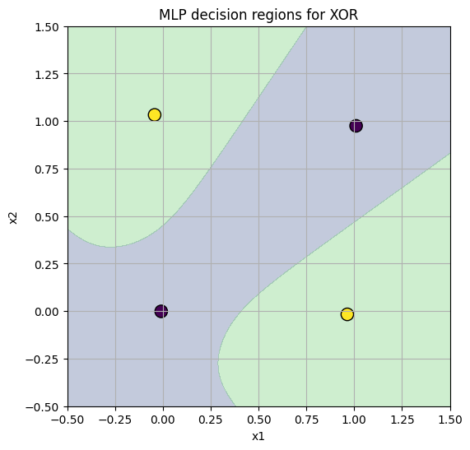
# Save model plot / results to files
plt.figure(figsize=(6,6))
plt.contourf(XX, YY, Z, levels=[-0.01,0.5,1.01], alpha=0.3)
plt.scatter(X_xor[:,0], X_xor[:,1], c=y_xor.flatten(), edgecolor='k', s=120)
plt.title('MLP decision regions for XOR (saved)')
plt.xlabel('x1'); plt.ylabel('x2'); plt.grid(True)
plt.savefig('/content/mlp_xor_decision.png', dpi=150)
plt.show()
print("Saved XOR decision plot to /content/mlp_xor_decision.png")

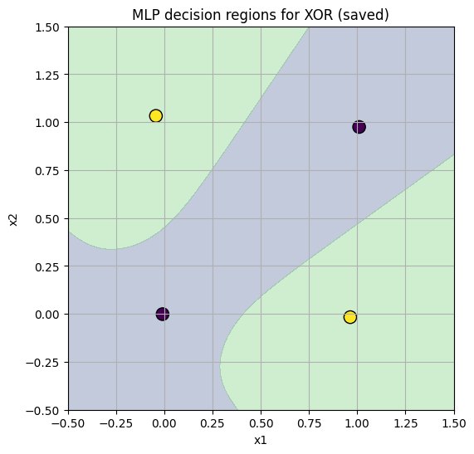
Saved XOR decision plot to /content/mlp_xor_decision.png

Conclusion:
The single-layer perceptron successfully classified the linearly separable AND dataset, while the MLP with a hidden layer accurately learned the XOR problem, demonstrating the necessity of multi-layer networks for solving non-linear classification tasks.

